Conformance Testing

Team 16:

Raghav Gupta

Chelsea Jaculina

Bala Nyan Kwaw

Mike Lee

Yihua Li

**April 15th, 2018**

**Professor Badari**

**CMPE 187**

# Table of Contents

**Table of Contents** **1**

**Overview** **2**

Introduction 2

Purpose 2

**Design of Control Panel** **4**

**Description of the problem** **5**

**Business Rules** **5**

**States and Transitions** **5**

**Finite State Machine (FSM)** **7**

**Transition Tours** **8**

**Test Cases** **9**

**Exceptions** **11**

**Lessons Learned** **12**

# 

# Overview

## Introduction

In this project, we are asked to design a control panel for an elevator that SJSU’s FDO (Facilities Development and Operations) needs since they have decided to add a new elevator to the College of Engineering building. The elevator needs to be built to cover all floors and be able to operate as a freight elevator when necessary. To fulfill this elevator design, our team will test build and test the design in an efficient matter.

The steps in order to design the control panel for the elevator include drawing up a diagram with the necessary buttons for the floors, freight, emergency stop, etc., define the business rules for the system, the states and transitions, and an FSM (finite state machine) depicting the states and state transitions. In addition, create transition tours from the FSM to test that our system is capable of handling these exceptions.

## Purpose

The sole purpose of this project is to use the technique of Conformance testing. Conformance testing is considered to be a testing methodology that ensures that a system or computer program meets a defined set of standards. For our team to understand and produce the most efficient elevator design for the College of Engineering, we must practice and understand each step of Conformance Testing. In Conformance Testing,

1. We must understand the description of the problem and gather a comprehensive set of business rules.
2. We must generate a diagram that depicts the total design for the elevator control panel.
3. We define a set of states and transitions for the system.
4. We must be able to create a FSM (Finite State Machine) that covers all the states and transitions.
5. We must make at least one transition tour from the FSM.
6. To know that we are building an efficient elevator, we must provide 5 test sequences that cover all the transition tours (TT) and clearly define any exceptions.
7. Finally, we must check for robustness by looking for exceptions that the system may run into, and how those exceptions will be handled.

Understanding the initial problem, creating a FSM, generating a comprehensive set of business rules, transition tours, test cases, and exceptions will give us good practice and understand the importance of Conformance testing.

# Design of Control Panel

[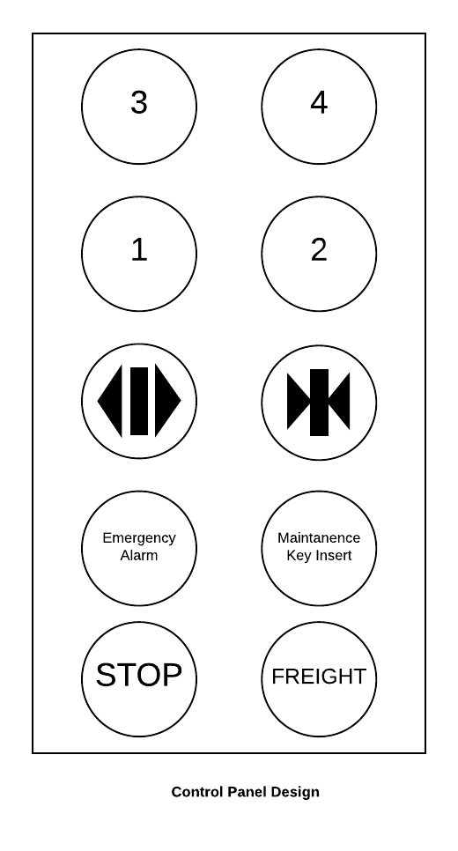](https://www.lucidchart.com/documents/edit/481d087c-cc3a-496a-b541-fd261568dc78/0?callback=close&name=docs&callback_type=back&v=2051&s=260)

Our control panel design for the new additional elevator includes a total of 8 buttons. The top 4 buttons indicate each of the 4 floors that are in the College of Engineering building. The third row of the control panel indicates buttons for users to either keep the elevator door open or closed. The bottom two rows on the control panel are options for an emergency.

# Description of the problem

The goal of this project is to help the SJSU FD & O (Facilities Development & Operations) to build an additional elevator system in Engineering building at San Jose State University. The new elevator must operate to cover all the floors and also be able to work as a freight elevator in case of any emergencies occur.

# Business Rules

1. The elevator will take passengers to their destination floor.
2. The elevator has only 4 floors.
3. The elevator will finish all requests in the same direction (going up or down) before it switches to the opposite direction.
4. The door will remain open while passengers request for the same floor.
5. Requests can be performed inside and outside of the elevator.
6. Passengers can press alarm button for help when there is an emergency.
7. The elevator can work as a freight elevator if needed.

# States and Transitions

|  |  |  |
| --- | --- | --- |
| Transitions | | |
| Symbol | Name | Definition |
| FRBP | Freight Button Pressed | User presses freight to set load parameter to freight. |
| NBP | No Button Pressed | No user using the elevator. |
| FBP | Floor Button Pressed | User select a floor to go. |
| ABP | Alarm Button Pressed | User alerts an emergency. |
| EMC | Exceeded Maximum Capacity | Weight of total load too heavy. |
| KI | Key Inserted | Key for maintenance inserted. |
| ER | Error Resolved | Error resolved. |
| A | Arrived | Elevator arrived at the queued floor. |

|  |  |  |
| --- | --- | --- |
|  | States | |
| Symbol | Name | Definition |
| S0 | Idle | When there is no request, the elevator will enter idle mode and wait for requests from users. |
| S6 | Freight Mode | The elevator will enter freight mode when user presses FREIGHT button. |
| S3 | Maintenance | The elevator will enter Maintenance mode when administrator insert the key. The elevator will not accept any requests from users under maintenance mode. |
| S1 | Move | When the elevator accepts requests from users, it will enter move state and take users to destination |
| S4 | Overloaded | If current weight in the elevator is more than the maximum capacity, the elevator will enter overloaded mode and stop working |
| S2 | Stop | The elevator enters stop mode when it finishes all users’ requests. |
| S5 | Emergency | When user presses the ALARM button, the elevator will enter emergency mode |
| S7 | Error | The elevator enters error mode when there is emergency or unexpected events occur which prevents it from working correctly |

# Finite State Machine (FSM)

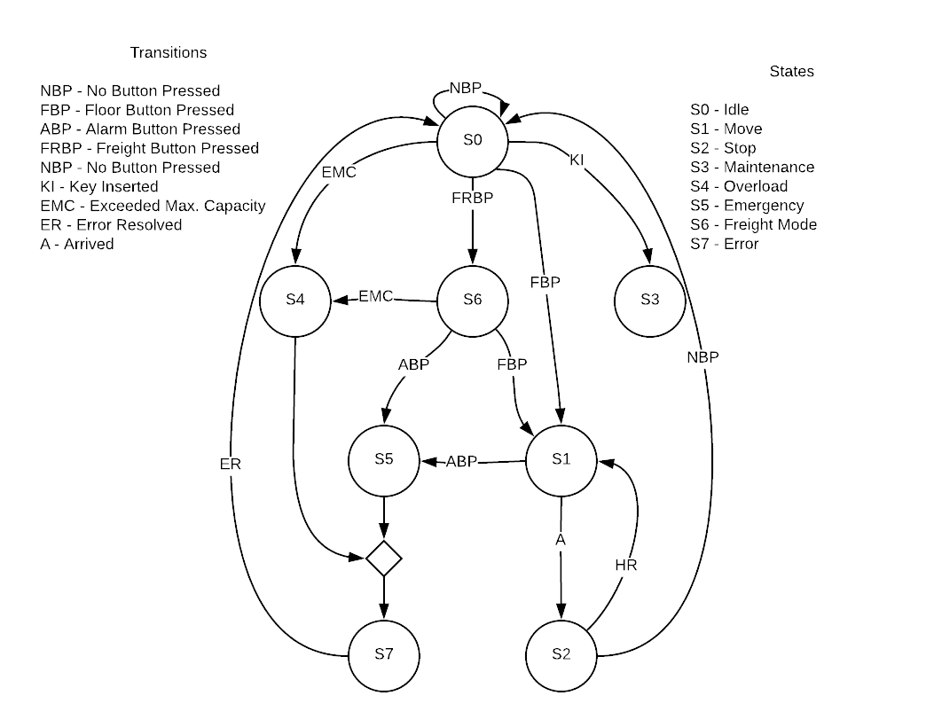

**Elevator FSM**

# 

# Transition Tours

A transition tour (TT) is defined as a sequence of state-transitions from the initial state to the final state. Below are transition tours that clearly comprehensively test all the business rules.

|  |  |
| --- | --- |
| **Transition Tour #** | **Sequence** |
| **1** | **Idle** → Key Inserted → **Maintenance** |
| **2** | **Idle** → No button pressed → **Idle** |
| **3** | **Idle** → Floor Button Pressed → **Moving** (Up/Down) → Arrived to Selected Floor → **Stopping** (Door Opened/ Door Closed) → Call Error → **Error** → Error Resolved → **Idle** |
| **4** | **Idle** -- Fright Button Pressed → **Freight** → Call Error → **Error** |
| **5** | **Idle** → Freight Button Pressed → **Freight** → Freight Exceeded Weight Limit → **Overload** |
| **6** | **Idle** → Weight Limit Exceeded → **Overload** |
| **7** | **Idle** → Freight Button Pressed → **Freight** → Emergency Button Pressed → Emergency → Call Error → Error → Error Resolved → **Idle** |
| **8** | **Idle** → Freight Button Pressed → **Freight** → Freight Moving → Moving (Up/Down) → Call Error → **Error** |
| **9** | **Idle** → Floor Button Pressed → **Moving** (Up/Down) → Moved to Selected Floor → **Moving** (Up/Down) → Emergency Button Pressed → **Emergency** |
| **10** | **Idle** → Floor Button Pressed → **Moving**(up/down) → Move to selected floor → **Stopping** (open door) → Elevator still has requests → **Moving** (up/down) → Move to selected floor → **Stopping** (open door) → Waiting for requests → **Idle** |

# 

# Test Cases

|  |  |  |  |  |  |
| --- | --- | --- | --- | --- | --- |
| **#** | **Reason** | **Input** | **Expected** | **Actual** | **Pass/Fail** |
| 1 | Check if freight mode works | Press FREIGHT button | Switched to freight mode and can take more weight | Switched to freight mode and can take more weight | Pass |
| 2 | Check if the ALARM button stops the elevator | Press ALARM button | The elevator will stop from working and call errors to administrator | The elevator will stop from working and call errors to administrator | Pass |
| 3 | Check if the button 2 works correctly | Press floor 2 button from floor 1 | The elevator will move up and stop at floor 2 | The elevator will move up and stop at floor 2 | Pass |
| 4 | Check if the button 3 works correctly | Press floor 3 button from floor 1 | If there is request to floor 2, the elevator will first move up and stop at floor 2, then move up again and stop at floor 3. If there’s no request to floor 2, the elevator will move up to floor 3 and stop | If there is request for floor 2, the elevator will first move up and stop at floor 2, then move up again and stop at floor 3. If there’s no request for floor 2, the elevator will move up to floor 3 and stop | Pass |
| 5 | Check if the button 4 works correctly | Press floor 4 button from floor 1 | If there are requests to lower floors(2 and 3), the elevator will move up to the lower floors and stop, then move up to floor 4 and stop. If there are no requests to lower floors, the elevator will move up to floor 4 and stop | If there are requests for lower floors(2 and 3), the elevator will move up to the lower floors and stop, then move up to floor 4 and stop. If there are no requests for lower floors, the elevator will move up to floor 4 and stop | Pass |
| 6 | Check if the button 1 works correctly | Press floor 1 button from floor 4 | If there are request for higher floors than floor 1, the elevator will move down to those higher floors and stop, then move down to floor 1 and stop. If there is no other requests, the elevator will move down to floor 1 and stop | If there are request for higher floors than floor 1, the elevator will move down to those higher floors and stop, then move down to floor 1 and stop. If there is no other requests, the elevator will move down to floor 1 and stop | Pass |
| 7 | Check if the elevator enters maintenance mode properly | Insert the key of the elevator | The elevator will enter maintenance mode and stop receiving request from any user | The elevator will enter maintenance mode and stop receiving request from any user | Pass |
| 8 | Check if the elevator sensors maximum capacity in normal mode | Weight: Over Maximum weight of the elevator can carry in normal mode | The elevator will detect overload, then signal the error and stop working | The elevator will detect overload, then signal the error and stop working | Pass |
| 9 | Check if the elevator sensors maximum capacity in freight mode | Weight:Over Maximum weight of the elevator can carry in freight mode | The elevator will detect overload, then signal the error and stop working | The elevator will detect overload, then signal the error and stop working | Pass |

# 

# Exceptions

|  |  |  |  |  |  |  |  |
| --- | --- | --- | --- | --- | --- | --- | --- |
| **#** | **Reason** | **Scenario** | **User Input** | **Expected** | **Actual** | **Pass/Fail** | **Sequence** |
| 1 | Maintenance Request Initiated | User has the maintenance key  Key switches to elevator to maintenance mode | Key is turned | The elevator does not operate and take any button that is pressed until the maintenance is done | Same | Pass | S0-S3 |
| 2 | Passenger that is inside requests the floor that the elevator is already on | The passenger pushes the floor button that they are currently already on | The same floor button is pressed | Elevator opens floor door at current floor | Same | Pass | S0-S2 |
| 3 | Overload | The maximum capacity is exceeded | The weight of people | Elevator won’t operate as our overload sensor will alert | Same | Pass | S0-S4-S2-S7 |
| 4 | Error | Power Outage | If the power suddenly shuts down and doors will not open | The elevator enters an error state and doesn’t operate to prevent an incidents | Same | Pass | S0-S3-S7 |

# 

# Lessons Learned

There were many lessons that our team learned during this project. The first lesson that our team learned was the importance of Conformance Testing and how effective the techniques FSM, Transition tours, Test Cases, and Exceptions are. The next lesson our team learned was how to generate a comprehensive set of business rules and understand the psychology that is needed to design an elevator to meet the necessary needs of covering all the floors in the College of Engineering building and operate as a freight elevator when necessary. By performing Conformance Testing to help us design an elevator we also learned how to clearly define our test cases.